**Assignment No.9**

**Roll No: -**

**Q. Write an ASP.NET program to demonstrate use of Master Page.**

**Assignment9.master:-**

<%@ Master Language="C#" AutoEventWireup="true" CodeBehind="Assignment9.master.cs" Inherits="March28.Assignment9" %>

<!DOCTYPE html>

<html xmlns="http://www.w3.org/1999/xhtml">

<head runat="server">

<title></title>

<asp:ContentPlaceHolder ID="head" runat="server">

</asp:ContentPlaceHolder>

<style type="text/css">

.auto-style2 {

width: 937px;

}

.auto-style3 {

width: 937px;

height: 294px;

}

.auto-style5 {

width: 937px;

height: 79px;

}

.auto-style11 {

width: 937px;

height: 49px;

}

</style>

</head>

<body style="height: 577px">

<form id="form1" runat="server">

<table class="auto-style1">

<tr>

<td class="auto-style5">

<asp:Image ID="Image1" runat="server" Height="154px" ImageUrl="~/Images/Yccsk.jpg" Width="989px" />

</td>

<td class="auto-style10"></td>

</tr>

<tr>

<td class="auto-style11">

<asp:Menu ID="Menu1" runat="server" Font-Size="Large" OnMenuItemClick="Menu1_MenuItemClick" Orientation="Horizontal" StaticSubMenuIndent="16px">

<Items>

<asp:MenuItem NavigateUrl="~/Home2.aspx" Text="Home " Value="Home "></asp:MenuItem>

<asp:MenuItem NavigateUrl="~/About2.aspx" Text="About us " Value="About us "></asp:MenuItem>

<asp:MenuItem NavigateUrl="~/Courses2.aspx" Text="Courses" Value="Courses"></asp:MenuItem>

<asp:MenuItem NavigateUrl="~/Contact2.aspx" Text="Contact us " Value="Contact us "></asp:MenuItem>

</Items>

<StaticMenuItemStyle HorizontalPadding="80px" />

</asp:Menu>

</td>

<td class="auto-style12"></td>

</tr>

<tr>

<td class="auto-style3">

<asp:ContentPlaceHolder ID="ContentPlaceHolder1" runat="server">

<p>

<br />

</p>

</asp:ContentPlaceHolder>

</td>

<td class="auto-style4"></td>

</tr>

<tr>

<td class="auto-style2">

<asp:Image ID="Image2" runat="server" Height="101px" ImageUrl="~/Images/Footer.jfif" Width="987px" style="margin-top: 0px" />

</td>

<td>&nbsp;</td>

</tr>

</table>

</form>

</body>

</html>>

**Home1.aspx:-**

<%@ Page Title="" Language="C#" MasterPageFile="~/Assignment9.Master" AutoEventWireup="true" CodeBehind="Home1.aspx.cs" Inherits="March28.Home1" %>

<asp:Content ID="Content1" ContentPlaceHolderID="head" runat="server">

</asp:Content>

<asp:Content ID="Content2" ContentPlaceHolderID="ContentPlaceHolder1" runat="server">

<p>

<br />

</p>

<p>

</p>

</asp:Content>

**\*\*\*\*\*\*\*\*\*\*\*\*\*\*\*\*\*\*\*\*\*\*OUTPUT\*\*\*\*\*\*\*\*\*\*\*\*\*\*\*\*\*\*\***

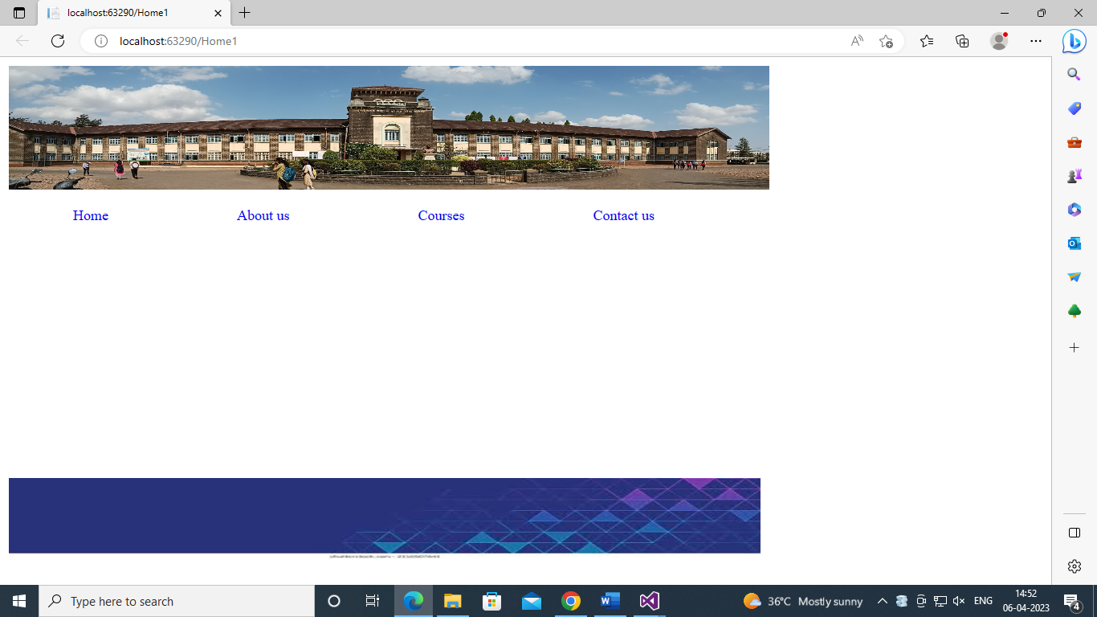

**After Click on Home.aspx:-**

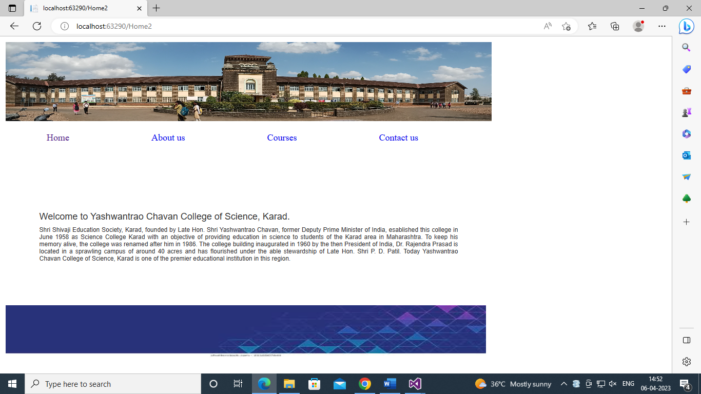

**After Click on Aboutus.aspx:-**

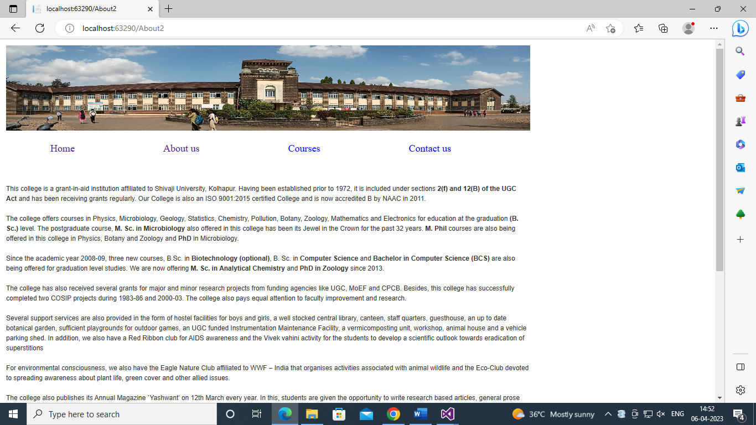

**After Click on Courses.aspx:-**

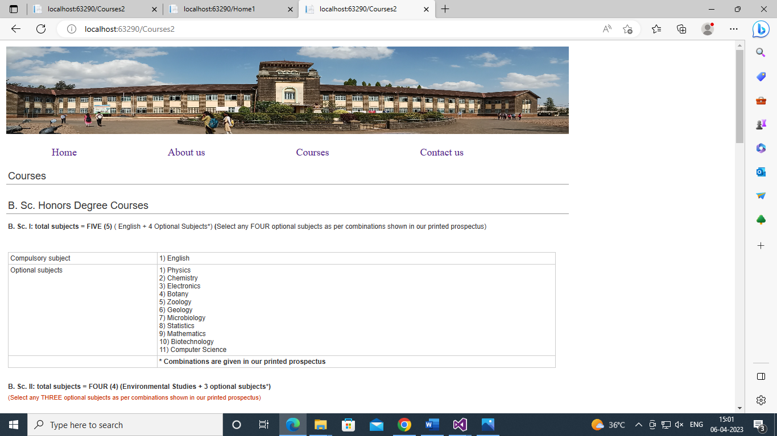

**After Click on Contactus.aspx:-**

